DCSI 100-008

Joel Ostblom

Email: joel.ostblom[-at-]ubc.ca

Office Hours: Fri 12-1pm. Zoom

When sending emails, please include DSCI 100 in the subject line.

Textbook: Data Science: A First Introduction

Using R programming language

Reports will be done using **Jupyter Notebooks** accessed via Canvas.

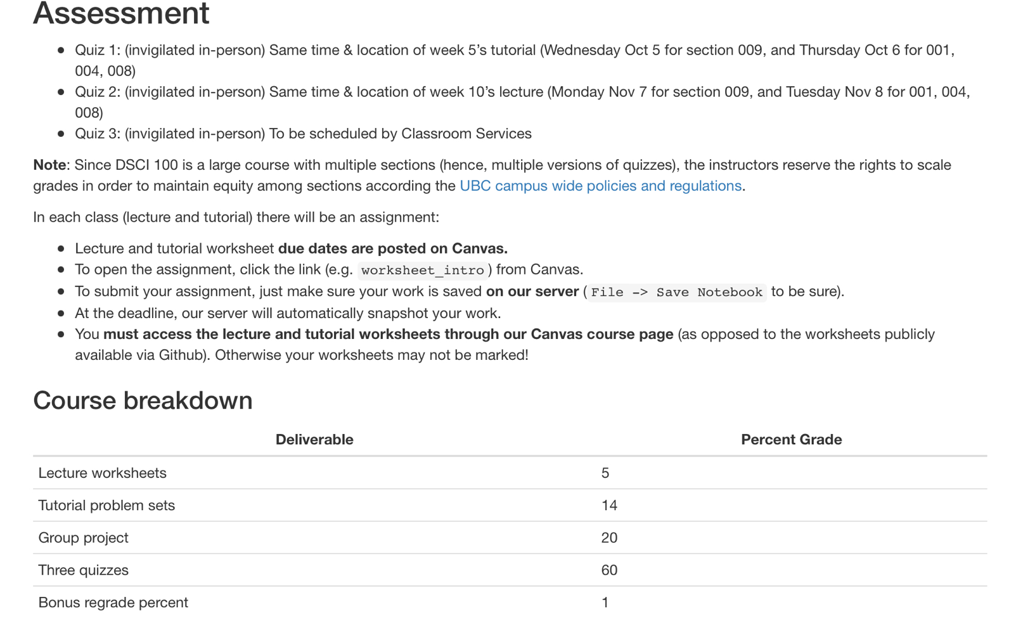TA



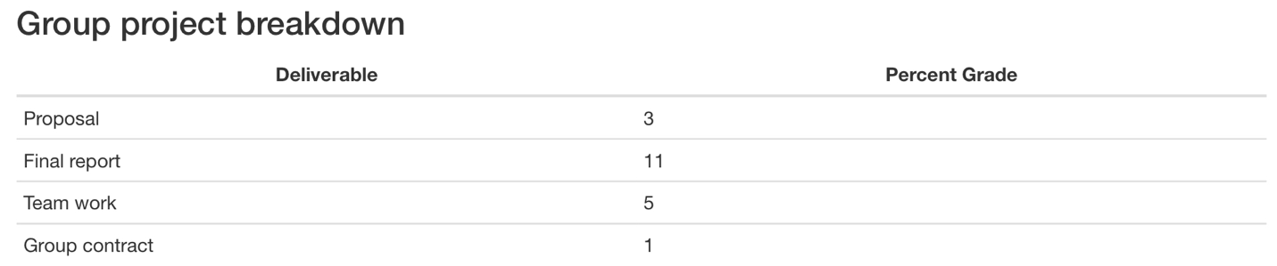

In short: whatever grade the autograder returns after 5 minutes (assuming the teaching team did not make an error) is the grade that will be assigned.

